Long Island, Boston Harbor

Total land area: 214 acres. 1.75 miles long.

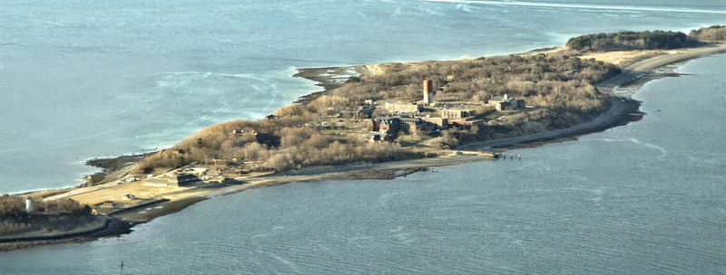
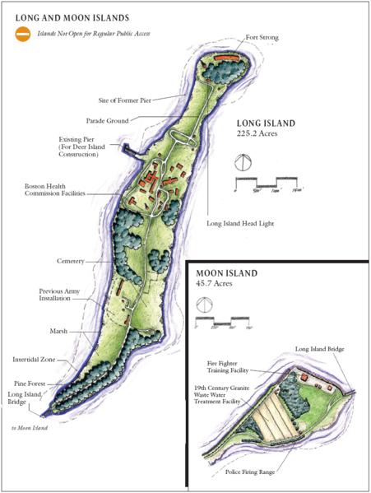

Welcome to Boston’s Long Island!

The information included in this document was sourced from a number of web searches which have been credited at the end of each article. This document is not intended for sale.
Table of Contents

Seventeenth century 2
Early Nineteenth century 5
American Civil War 7
Post Civil War 7
Development of the Modern Fort Strong 8
Twentieth century 10
Recent use 10
Long Island Hospital - Biographical/Historical note 12
Submarine mines in U.S. harbor defense 16
The Farm at Long Island Shelter 19
Camp Harbor View 20
Friends of Boston’s Homeless 21
Providing Solutions to Homelessness 21
Friends of the Boston Harbor Islands 22

Seventeenth century
Long Island was originally used and populated by Native American Indians, and during the American colonial period. On April 1, 1634, the island was granted to the City of Boston along with Deer Island and Hogg Island (now Orient Heights in East Boston). The rent for these three islands was set at two pounds per year. This grant was confirmed on March 4, 1635 when Spectacle Island was added to the package and the annual rent was reduced to four shillings per year for all four islands.
The Town of Boston leased Long Island to thirty-seven tenant farmers for farming and for the felling of trees. Wood was a much needed commodity in this period since it was the main fuel used for cooking and heating of houses in Boston. Long Island derived its name from its length—a mile and three-quarters long and a quarter mile wide. William Wood in his New England Prospect reported that this isle abounds in wood, water, meadow ground, and fertile ground. He also noted that local farmers put their rams, goats, and swine here for safety during the corn growing season.
On February 24, 1640, the Boston Town Meeting ordered that Long Island be laid out into lots for farming starting at the eastern point on the island. On September 28, 1641, the Right-Honorable William, Earl of Stirling, filed an ownership claim for Long Island. His colonial agent, John Forest, recorded the Earl's claim against Edward Tomlin and others as intruders on Long Island. This claim was proven baseless by the Court in Boston.
On April 19, 1649, the Court in Boston levied an annual rent of 6 pence per acre on the farms on Long Island with payment due on February 1 each year. The proceeds from these rents were slated for the support of the free school in Boston. Because the Long Island tenants refused to pay these rents, in 1655, Boston officials sent a constable out to the island to make the necessary collections.
On March 11, 1667, the Town of Boston deeded the farms on Long Island to the tenants with the stipulation that they pay up their back rent. By this act, the land on Long Island first passed into private hands. During 1672, Joseph and Elizabeth Rock purchased 41 acres (170,000 m²) on Long Island with a mortgage which they paid off by August 9, 1672. The deed described their property as having houses, outhouses, barns, stables, wharfs, yards, orchards, gardens, meadows, pastures, and fishing rights.
In the 1670s during King Philip's War, Christian "praying Indians" were moved from Marlborough and Natick under the auspices of John Eliot, the minister of Roxbury, mostly to Deer Island, but at least one colony was sent to Long Island.^{[5]}
On October 6, 1676, during the panic caused by King Philip's War, Massachusetts residents collected all of the local Native American population from the surrounding towns and herded them to a dock in Watertown on the Charles River. Here, they were loaded on barges and transported to Deer Island where they were abandoned. Through the freezing winter, the Indians' main sustenance was fish and clams taken along the shore and mud flats of the island. No barracks or other housing were provided, and only a scanty thicket on the lee side of the hills protected them from easterly winds. Thousands of Native Americans are presumed to have been marooned on Deer Island that winter; however, only the converted (praying) Indians were counted and recorded. Hundreds of Indians perished of starvation and exposure during the winter of 1676-77. Old Ahatton and other chiefs petitioned the Court in Boston for the rights to visit other islands in Boston Harbor to harvest clams and fish because his people were starving to death. In the Spring of 1677, the surviving Indians were allowed to cross over to Long Island.

Eighteenth century
On December 7, 1708, Benjamin Browne, one of the mortgagers of Nelson's Island, died, passing control of the island to his brother, William Browne, who died on February 23, 1716. John Nelson died on December 5, 1721. On September 24, 1724, the land-deed given from John Nelson to the Brownes was declared a mortgage and was annulled by a legal instrument executed by Colonel Samuel Brown, who acted as executor for the Brownes. The ownership of Nelson's Island had reverted to Nelson's heirs in seven parts. Two parts went to John and Mary Nelson, heirs of the oldest son, Temple Nelson. One share went to Nathaniel Hubbard by his wife, Elizabeth Nelson. One part went to Henry Lloyd by his wife, Rebecca Nelson. Another part went to John Steed by his wife, Margaret Nelson, and one part went to Robert Temple by his wife, Mehitable Nelson. Robert Nelson bought up an additional four shares.
Robert Temple and the other owners sold the whole of Nelson's island to Charles Apthorp, a merchant from Boston. The deed described the island as containing 200 acres (0.8 km²) of land, single houses, buildings, barns, stables, orchards, gardens, pastures, fences, trees, woods, underwoods, swamps, marshes, meadows, arable land, ways, water courses, easements, commons, common pasture, passages, stones, beach, flats, immunites, commodies, heriditaments, emoulants, and apportances. The name used for the island changed to Apthorp's Island at this time, although both names are found in various records. Charles Apthorp died on November 18, 1758 at 60 years of age. His heirs sold the island to Barlow Trecothick, an alderman and Lord Mayor of London. Trecothick had married Grizzell Apthorp, the oldest daughter of Charles Apthorp and Grizzell Eastwicke Apthorp.

American Revolutionary War
During the Revolutionary times in 1768, the occupying British forces used Long Island for grazing their sheep, cattle, and swine. The British also harvested the hay from this island's meadows as feed for their horses in Boston.
On July 12, 1775, Colonel John Greaton with a detachment of 500 American soldiers, in 65 whaleboats, raided Long Island where they "liberated" all the sheep and cattle grazing there, and captured 17 British sailors who were guarding the animals. British men-of-war, when alerted about the raid, fired at the whaleboats. A British schooner, towing barges loaded with armed marines, chased the American whaleboats back to their encampment in Squantum and Dorchester. One American soldier was killed on Moon Island. Moon Island was not connected to Squantum at this time and a waterway was open from behind Squantum (Squaw Rock) across the mouth of the Neponset River to a large rock called Savin Hill.
On Sunday, March 17, 1776, British ships evacuated Boston under pressure from George Washington's forces on the heights on Dorchester (now South Boston). Abigail Adams, from her vantage point in a part of Braintree that is now Quincy, described the sight of the myriad masts of the British fleet as like a forest in the harbor. On board the British ships were 11,000 soldiers and sailors and 1019 self-exiled citizens of Boston, including 102 civil officers, 18 clergymen and 105 loyalists from the country towns.
Instead of immediately departing the Boston Harbor area, the British ships anchored in the outer harbor and continued the blockage of Boston Harbor for the next three months, which was a cause of great concern in Boston and the surrounding towns. British Commodore Banks on his 28-gun "Milford" and several other men-of-war commanded the blockading British fleet. As the blockade persisted, Abigail Adams was quite outspoken about the delay by the Boston authorities in removing the British blockade from the outer harbor. During June, fierce artillery battles were waged between the British ships and American shore batteries that were entrenched on the harbor islands. The embarrassment from her remarks may have triggered the following actions:
One June 13, 1776, American General Ward ordered Colonel Asa Whitcomb and 500 cannoneers with a 13-inch (330 mm) mortar and two field cannons to the East Head of Long Island, while similar emplacements were set up on Hull. This installation was named, "Long Island Battery." At a signal from their commander, Brig. General Benjamin Lincoln, both batteries opened fire on the British fleet. When the British flagship, "Milford" was hit, Commander Banks ordered the rest of the British fleet to sea.
During the confusion created by the cannonading by American artillerymen from East Head on Long Island and from the Hull Batteries, two American privateers attacked the British transport, "Arbella," that was loaded with rich supplies and Scottish Highlander troop replacements. The Arbella was on an approach to Boston Harbor and beat off the initial attack, escaping up Nantasket Roads into the channel off the East Head of Long Island. Obviously, this British transport did not get the word about the evacuation of Boston. Captain Tucker's Marblehead, Massachusetts privateer took up the chase from Broad Sound along with an armed vessel from Rhode Island that approached the Arbella from the east side of Long Island. They found that the Arbella had grounded but was still able to fight, as her guns shattered Tucker's spars and riddled his ship's sails and Pine Tree flag. The transport then turned and drove the Rhode Island privateer around the west side of Long Island. The fight continued until the British ship struck her colors. British captain Major Menjies and 36 men were killed during the battle. The slain Highlanders were buried on Long Island in a solemn procession led by Scottish bagpipers. The wives of the dead soldiers who had accompanied their husbands on this trip marched in the funeral procession. The rich cargo of military stores was quickly moved to Cambridge to help support the American army that was encamped there.
On July 17, 1776, about a month after the British were driven from the outer harbor, the Long Island Battery on East Head fired a thirteen-gun salute in celebration and honor of the promulgation of the Declaration of Independence. Similar salutes were fired from the other batteries throughout Boston Harbor.
Edward Rowe Snow related a story about a Mary, the wife of a Tory, William Burton, who was aboard one of the British ships that formed the blockade on Boston Harbor, together with her husband. A cannonball from the Long Island Battery struck Mary. As she lay dying, she pleaded with her husband not to bury her at sea. A flag of truce was struck that allowed Burton to go ashore with his wife's body. Mary Burton was buried on East Head after her body was sewn into a red blanket. One of the Americans agreed to put her name on a grave marker. Her husband planned to return to Boston but never did. Over the years, the wooden marker rotted away. People who knew this story erected a stone cairn over the burial site. In 1804, some fishermen were wrecked on Long Island and they took refuge in an old powder magazine. As they were building a fire, they were startled by a moan coming over the hill near Mary Burton's cairn. The stunned fishermen claimed to have seen a form of a woman wearing a scarlet cloak coming over the hill. Blood appeared to be streaming down the cloak from a wound in her head. The ghost just kept on walking by the fishermen and soon disappeared over the hill. Again, during the War of 1812, a "woman in scarlet" was reported at Fort Strong. Also, in 1891, Private William Liddell reported seeing a "woman in scarlet." Liddell, while on guard duty at night, reported that that ghost came toward him from an easterly direction emitting distinct moans.
Barlow Trecothick, the owner of Long Island, died on May 28, 1775 and the island passed to his brother-in-law, Charles Ward Apthorp from New York (died 1796). Apthorp sold the island on June 13, 1791 to James Ivers of Boston. Around this time, the island began to be officially called Long Island.
In 1794, a lighthouse was built on the northern head of the island, replaced by a bigger tower in 1819. It was later relocated to fit in with coastal fortifications.

Early Nineteenth century
In 1814, during the War of 1812, the Massachusetts authorities requested that Commodore Bainbridge move the new ship, "Independence" and the frigate, "Constitution" down the harbor so that the British could capture them, hoping to avoid having the British shell the City of Boston. Bainbridge refused and suggested that Long Island be fortified to keep the British from entering Boston Harbor.
During 1818, a committee from the Boston Marine Society investigated the need for a lighthouse on Long Island Head, acting on a request from the Portland (Maine) Marine Society. This lighthouse would be designed to help vessels navigating into Boston Harbor through the Broad Sound Channel.
Another committee of five selected a suitable site for a lighthouse during April 1819. The first lighthouse built on Long Island Head was constructed on the eastern side of Long Island Head. The finished light was a 23-foot (7 m) rubble stone and granite tower. The lantern was positioned about 109 feet (33 m) above MHW-Mean High Water. (The height of a light is measured from MHW to the focal plane of the light source or bulb. The light's characteristic was a fixed white beam generated from nine burners and reflectors with a visibility of about 15 nautical miles (28 km). This light, called the "Inner Harbor Light", was the second lighthouse established in Boston Harbor. The first light keeper was Jonathan Lawrence. The 35 acres (140,000 m²) needed for this first lighthouse had to be acquired by the Federal Government by a lawsuit. The "Inner Harbor Light" was first lighted during October 1819. The lighthouse property was surrounded by fortifications located along the edge of the cliff.
Jonathan Lawrence, who was the first lightkeeper at Long Island Light, died in the Light Service in 1825. Charles Beck, the second light keeper ran a signal system from Long Island Head in 1825. Beck hoisted a black ball to indicate when more pilots were needed down the harbor. This signal system remained active until 1851.
During 1844, a new cast-iron lighthouse was constructed on Long Island Head. This was the second lighthouse built on the Head. It appears to be the first cast-iron lighthouse constructed in the United States. The South Boston Iron Company performed the work. This lighthouse was cast in sections of about seven feet in height and twelve feet in diameter at the base. It was furnished with an iron deck providing a twenty-inch walkway around the lantern. The deck had a railing. A cast iron circular staircase on the interior led to the lantern room. The lantern was made of upright wrought iron bars to receive the glass with sixteen 48" x 16" side over which was a cast iron dome with a cast-iron pipe in the center that served as a smoke flue for the lighthouse's stove.
On October 1, 1847, the Ivers' heirs sold Long Island to Thomas Smith of Cohasset, Massachusetts. The East Head, where the lighthouse was located, was not included in this sale. Long Island was on the verge of being developed, but an ominous rumor about a pending takeover by the City of Boston for its various institutions made this real estate undesirable to investors. The use of this island as a military post precluded any recreational expansion and development.
On May 1, 1849, Long Island was purchased from Thomas Smith and was incorporated by the Long Island Company. At this time, the only inhabitants were George Smith, a farmer, and Nicolas Capello, a Portuguese fisherman. Over the next 35 years, the heirs of Nicholas Capello and other friends increased the population of Long Island to over thirty families clustering in an area called "Portuguese Village". Their huts and a fleet of fishing boats were located just below East Head.^{[8]}
The Long Island Company built the Long Island House and the Long Island Hotel in the center of the island as part of a project to develop recreational facilities on the island. A Colonel Mitchell was the proprietor of the Long Island Hotel. This hotel was described as a "splendid hotel, large and accommodating, constructed in the form of a Greek Cross and located in the center of the island on the west side". Colonel Mitchell was known as being welcoming, benevolent, and gentlemanly. The Eutaw House was also constructed at this time.^{[9]}
The Long Island Company drew up plans to subdivide Long Island into many small lots and envisioned a large new community. "Pleasure" or vacation brochures of Boston Harbor described the Long Island House as a "large white hotel." The rest of the island was meadows and grazing field. Many of the trees were long since cut down for firewood by early settlers.
In 1855, the second Long Island Light was refitted and repositioned into a square enclosure on the wastop of the Head. A good fresh-water was added and a comfortable, stone lightkeepers house was built. The remains of an old military fortifications formed the north and west side of the lighthouse enclosure. The new light was fitted with a Fourth Order Fresnel lens that exhibited a fixed white light and was located where it was visible toward Broad Sound. This light served as part of a range in conjunction with Bug Light on the end of Brewster Spit at the edge of the Narrows Channel. Vessels approaching Boston from the southeast would align these lights to stay clear of Hardings Ledge off Nantasket Beach. Bug Light was constructed in 1856 and showed a fixed red light.

American Civil War
In 1860, control of the Long Island Company was transferred to Thomas J. Dunbar of Boston. The plan to develop this island was thwarted by the rumors of war and plans for military installations on Long Island Head and other parts of the island. Camp Wightman was established on Long Island. The Commander was General Devens who used the Long Island House as his headquarters building. This military post was named after Mayor Wightman of Boston. On April 17, 1861, the 3rd Massachusetts Regiment departed Long Island along with the 4th Massachusetts Regiment, sailing to Fort Monroe, Virginia. These famous regiments were credited with destroying the navy yard at Norfolk, Virginia, and fought the Virginians at Hampton. On their return from the South, the 3rd Massachusetts Regiments were mustered out after four days in camp here. The men of the 4th Massachusetts Regiment were the first northern troops to march on Virginia soil during the Civil War. They also fought at Big Bethel. The 4th Massachusetts Regiment was also mustered out at Camp Wightman on Long Island.
During April and May 1861, Thomas Cass, formerly commander of the Massachusetts militia organization known as the Columbian Artillery, recruited the 9th Massachusetts Regiment. This regiment was composed almost totally of Irishmen. Cass became the first regimental Colonel. The 9th Massachusetts Regiment was conscripted from Salem, Marlboro, and Stoughton. The regiment arrived at Camp Wightman aboard the "Nellie Baker" on May 12, 1861 as part of the 13th Massachusetts Regiment. Training was completed through May and part of June. On June 11, there were mustered into the U.S. Army as the 9th Massachusetts Regiment. On June 25, 1861, the 9th Regiment sailed to Washington, D.C. from Long Island on the steamers "Ben De Ford", "Cambridge" and "Pembroke." Lieutenant Colonel Patrick Guiney became second in command to Cass.
In 1863, Camp Wightman had over 1,000 recruits in addition to several full batteries of heavy artillery under the command of General Devens. The military reservation was located on the slope between the Portuguese Village near the southeast beach and the summit beyond the Long Island House. The steamer "Bellingham" was the conscript boat for Fort Wightman on Long Island.
Many deserters drowned in the waters around Long Island as U.S. Army recruits tried to get to the mainland. At the time, it was the custom to induct and train recruits on islands to minimize desertions. A major scam at the time was for a man to sign up for the Army and collect an enlistment bonus. Then, after going AWOL, he would sign up again in another town, collecting an additional bonus. Islands, especially, during the winter months, contained the recruits with the surrounding frigid seawater. Winters in Boston Harbor were so cold that men walking guard duty had to be relieved every thirty minutes to avoid frostbite.

Post Civil War
During 1865, P.B. Small was reported as the light keeper on Long Island Light. During this year, the schooner "Joseph Fish," carrying 1,200 barrels (190 m³) of petroleum, was rammed by another vessel while at anchor near Long Island. Light Keeper Small reported that the "Joseph Fish" caught fire and was totally destroyed.
In 1867, the Federal Government acquired the east head section of Long Island by an act of Congress, and Fort Strong was moved to Long Island from Noddles Island (East Boston). The fort has been reported to be named after Major General George C. Strong, who was killed at Fort Wagner, South Carolina in 1863. History has shown the Fort Strong existed back in 1815 on Noddles Island.
During 1870, a 10-gun battery was constructed at Fort Strong on East Head on Long Island. In 1872, a large hotel was built on the current site of the Long Island Chronic Disease Hospital.
Long Island became the site of illegal recreational activities. A very popular event on Sunday evenings was prize fighting. On June 29, 1873, the Boston Police raided Long Island and put a stop to these illegal events.
During 1874, the gun blocks and a magazine for the Long Island Head Battery were constructed. These batteries remain today. During 1881, a new cast iron lighthouse was constructed along with a new keeper's house. This was the third lighthouse built on Long Island Head.
In 1882, as was rumored earlier, the City of Boston began purchasing property on Long Island for institutional care facilities: firstly an Almshouse, later (1921)^{[11]} a residence for unwed mothers, a chronic disease hospital, a nursing school and an institutional farm. The large hotel built in 1872 was part of the purchase. This hotel was used for City of Boston charities. During this year, male paupers were moved to Long Island from Rainsford Island.
On January 3, 1885, the Boston City Council passed an order to take possession of Long Island. The island has never returned to private hands since that date. Boston acquired Long Island from the heirs of Thomas Dunbar for $140,000. Buildings were immediately erected for a "Home for the Indigent." These buildings housed 650 people in 1885.
Sweetser described Long Island as conspicuous by its municipal buildings, and still more by its lighthouse perched on the very tip of the steepest cliff in the harbor, eighty-feet above the high water mark and visible for fifteen miles (24 km) at sea. The battery, which crowns the cliff, presenting only a range of green mounds to the view of the passing sailor, is a formidable little work, of modern construction, with walls of great thickness, bombproofs, and other defenses, partly separated from the rest of the bluff by a deep dry moat.

Development of the Modern Fort Strong
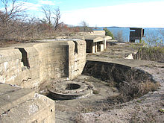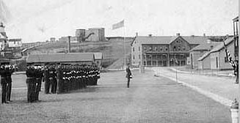
10-inch gun emplacements at Fort Strong. An early 20th century scene at Fort Strong.
In 1893, a huge construction project was begun, to build the massive concrete gun emplacements for the 10-inch guns of Fort Strong, one of the new Coast Artillery forts^{[12]} planned to defend Boston Harbor. The works for these larger batteries still exist today on the northern head of the island (see map at right). These northern emplacements^{[13]} were complete by 1899. Work continued on the 3-inch gun positions on the east and west sides of the parade ground (Batteries Taylor, Basinger, Smyth, and Stevens). These smaller calibre batteries were completed in 1906.
The fort, which had previously consisted of a battery of muzzle-loading cannon atop the northeastern head of the island,^{[14]} was now equipped with the latest in coast artillery, as part of nationwide improvements in coastal defense capabilities recommended by the Endicott Board.^{[15]}
Construction at the fort would continue through the 1920s, eventually creating a total of eight new batteries of 3-inch, 4.7-inch, and 10-inch guns along three sides of the island, extensive facilities for deploying and recovering the tethered mines which filled the nearby channels, and barracks space for over 1,000 members of the Coast Artillery who served at the fort.^{[16]}
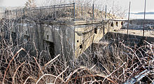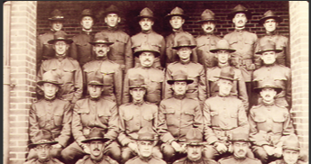
(left) 3-inch Gun Platform #1 of Battery Smyth, Fort Strong. (right) Officers in training at Fort Strong, a U.S. army base in Boston Harbor, before their deployment in 1917 to U.S. Army Base Hospital No. 6, a medical unit in Talence, France, run by the MGH during World War I. source: www.massgeneral.org/history/exhibits/front-lines/
Long Island Head was centrally situated in Boston Harbor, and the six 10-inch guns of Batteries Hitchcock and Ward (later reduced to five) had an effective range of roughly seven miles, letting them reach Revere on the north, Hingham on the south, and well out to sea in front of the harbor channels.
Prior to World War II, the Mining Casemate (see more information at page 17) at the fort controlled all the submarine mines that protected the southern approaches to Boston Harbor.^{[17]} The rapid fire 3-inch gun batteries constructed on all three shores of the fort overlooked these minefields to destroy attacking ships that might become entangled in them.
By World War II, only the 3-inch guns of Batteries Basinger and Smyth, plus a battery of anti-aircraft cannon, remained in service, and with the end of the war, the fort was declared surplus. In the 1950s, two buildings supporting the Nike missile system (since decommissioned, additional information at http://www.techbastard.com/missile/nike/bo37.php) were built on the island, and a target tracking radar was constructed at the northwest end of the North Head, in one of the former gun positions of Battery Drum.^{[18]}

Twentieth century
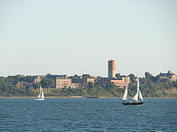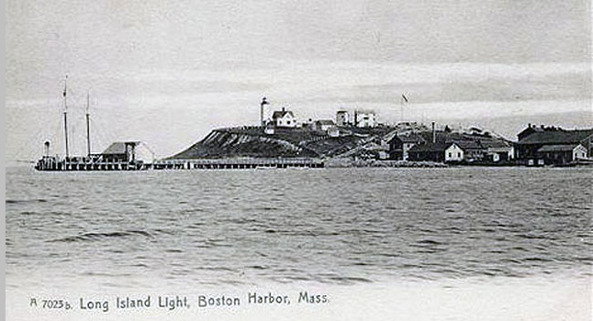
(right source: http://www.antifascistencyclopedia.com/wp-content/uploads/2010/08/0819_post-card-640.jpg)

Boston Public Health Commission facilities on Long Island. The old water tower is used by airplane pilots as an FAA visual clue and has checkered markings at the top. From Left to right: Our Lady of Hope Chapel (vacant), the old Administration Building, the Nichols Building, The (Mary) Morris Building behind, the newer McGillivray Building with dining room, the Tobin Building, and the Curley Auditorium (vacant) on the far right
In 1928, homeless men were housed in an addition to the former hotel, and in 1941 another addition housed a treatment center for alcoholics.^{[11]} New men's dormitory facilities were built and dedicated as the Tobin building, the cornerstone having been laid on November 9, 1940. It was named after Maurice J. Tobin, then Mayor of Boston.^{[19]}
In 1941, Boston's almshouse (see page 12 for more information) was located there, as well as the Chronic Disease Hospital. 1,400 patients and inmates were on the island, cared for by several hundred doctors, nurses, and employees. At that time, Dr. James V. Sacchetti was the medical director in charge.^{[10]}
Until the 1950s when a bridge was built from the adjacent Moon Island, the only transportation access to the island was by boat or a regularly scheduled ferry from Boston. The dedication plaque at the outbound entry to this bridge at Squantum, says it was built in 1950-51 by the Institutions Department of the City of Boston, and calls it the "Long Island Viaduct". Moon Island is connected to the mainland Squantum peninsula of North Quincy by a causeway.

Recent use
Long Island is currently used to support social service programs, as it has since 1882, contained in Boston Public Health Commission^{[20]} Long Island Health Campus facilities in 19 buildings on 35 acres (140,000 m²). This large campus of buildings presently houses the Long Island Shelter^{[21][22]} for the homeless in the Tobin Building since 1983, Project S.O.A.R.^{[23]} in the Administration Building since the Fall of 1995, Pine Street Inn's^{[24]} Anchor Inn, Andrew House (which moved there in 1987 from Dorchester, Massachusetts), the Wyman Community Re-entry Program ^{[25]}, Joelyn's Family Home ^{[26]}, and others.
There are many buildings that are not in use which were once very active. Examples of these are The Curley Building (which once housed a performing arts auditorium for the population and named after the former Mayor of Boston, James Michael Curley), Our Lady of Hope Chapel, and a crematorium, amongst others. Most of the campus was connected by tunnels as were most hospitals and universities at the time.
Boston Fire Department's Engine Company 54^{[30]} station house is located right on the island, adjacent to the campus.
Historical buildings and cemeteries dating from the Civil War to the Cold War can be found on the island, along with a large checkered red and white pattern water tower used as a navigational aid by the FAA for navigation into Logan International Airport. There is also a working organic farm which is 2 acres (8,100 m²) large and harvests approximately 25,000 pounds of produce which is used by the kitchens of the homeless shelters, and sold at farmers markets, and used by restaurants in Boston. It is staffed by residents of Long Island.
In 2007, Mayor Thomas Menino of Boston helped found and get private funding for a childrens day camp on Long Island, called "Camp Harbor View". (see more at page 20)
It was dedicated in March 2007 and has baseball fields, swimming, classrooms, and many other activities. The number of campers each summer is about 800. It is located where the former marching grounds were, south of Fort Strong and the lighthouse.^{[33]} A summer camp called "Harbor Discoveries" operated by the city.
Long Island allegedly served as inspiration for Dennis Lehane's Shutter Island.
Source: http://en.wikipedia.org/wiki/Long_Island_(Massachusetts)
Map of Fort Strong
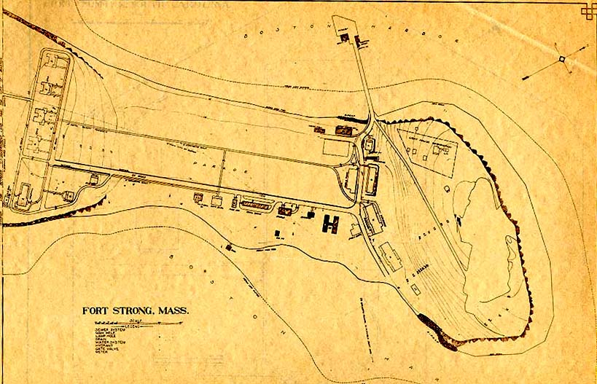
Source: http://ed-thelen.org/J-McGrath/ftstrongm.jpg

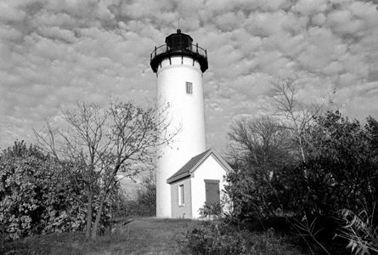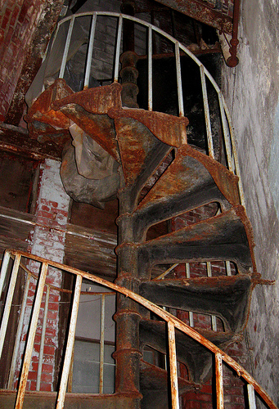
Long Island Light Spiral staircase in the old power plant.
Station established: 1819; Current lighthouse tower built: 1901; Deactivated: 1982-85, relighted 1985
Construction material: Brick; Tower height: 52 feet; Height of focal plane: 120 feet
Earlier optic: Fourth-order Fresnel lens (1857); Present optic: 250mm (solar powered)
Characteristic: Flashing white every 2.5 seconds Owner: National Park Service
Source: http://www.nps.gov/boha//images/20071203233642.jpg
Source: www.flickr.com/photos/massdep/3954680156/

Long Island Hospital - Biographical/Historical note
An almshouse was first erected in the Town of Boston in 1662. The first building burnt down. In 1682, the town voted to rebuild it and specified the object of the institution: it was “for the relief of the poor, the aged, and those incapacitated for labor; of many persons who would work, but have not the wherewithal to employ themselves; of many more persons and families, who spend their time in jolliness and tipling [sic], and who suffer their children shamefully to spend their time in the streets, to assist, employ, and correct whom the proposed institution was provided.” The Boston Almshouse was established in 1725 on Beacon Street. The building on Beacon Street was discontinued in 1801 and a new almshouse was built on Leverett Street. The need to separate the “worthy poor” from the “vicious poor” led to the establishment of a House of Industry and a House of Correction in the 1820s. The almshouse on Leverett Street was sold in March of 1825. The poor were transferred to the House of Industry in South Boston.
The Almshouse Department within the House of Industry held responsibility for all the paupers who were admitted to the House of Industry. In 1853, the House of Industry was removed to Deer Island. Due to population constraints at the Deer Island facility, all of the male paupers in the Almshouse were transferred to the newly opened Home for the Poor on Rainsford Island in October 1872. All the female paupers were transferred to the Home for the Poor at Austin Farm in April 1876. Finally, in 1877, the boy paupers were moved to the Marcella-street Home and the girl paupers followed in 1881.
In 1887, the female paupers were transferred from Austin Farm to the Almshouse at Long Island. One year later, in 1888, the male paupers and female paupers traded places. The men moved to the facilities on Long Island and the women relocated to the buildings on Rainsford Island. In 1894, the male and female paupers were consolidated on Long Island in the newly established Boston Almshouse and Hospital. In December 1924, the name of the Boston Almshouse and Hospital was changed to Long Island Hospital since many attached a negative connotation to the word “almshouse.”
In 1920, all the individual departments were consolidated into the Institutions Department. The Infirmary Department became a division within the Boston Almshouse and Hospital. On June 1, 1954, the Long Island Hospital was transferred out of the Institutions Department and became the Long Island Division of the Hospital Department. At this time all responsibilities for those once classified as “paupers” passed to the Welfare Department.
Source: http://www.cityofboston.gov/archivesandrecords/Guide%20to%20the%20Almshouse%20records.xml
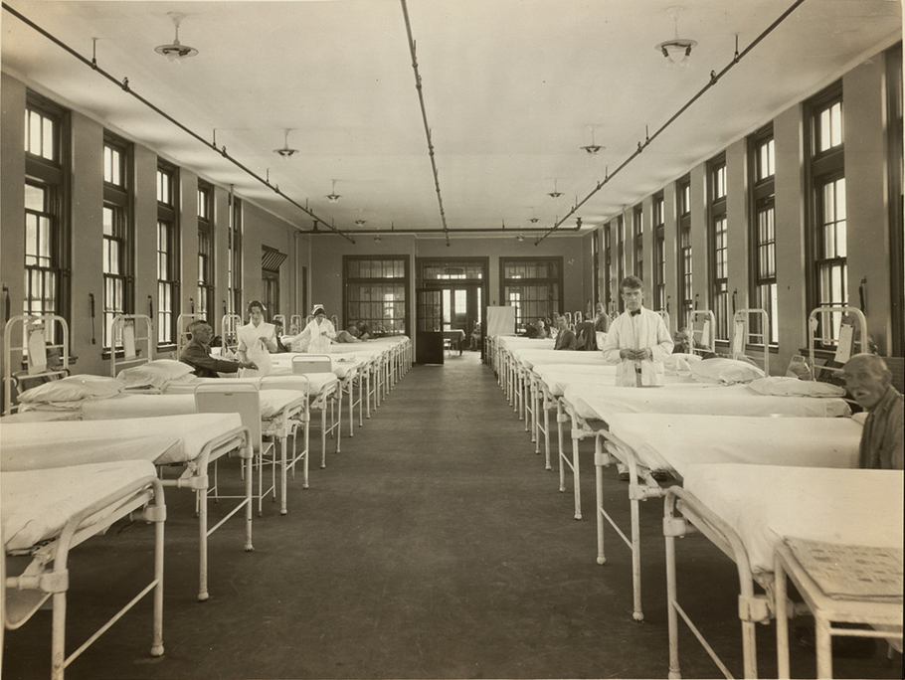
Nurses and patients in hospital ward on Long Island, Boston Harbor
Source: http://www.flickr.com/photos/24029425@N06/5640115463/ Boston Public Library
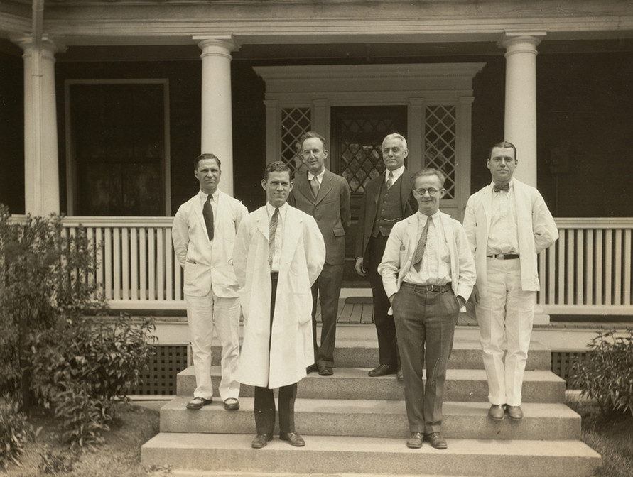
Portrait of men, possibly doctors or other medical personnel, standing in front of building on Long Island source: http://www.flickr.com/photos/boston_public_library/5640114841/in/photostream/
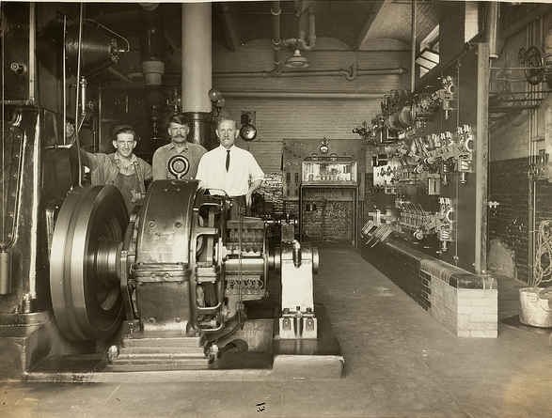

Men standing in room with machinery on Long Island Source: http://www.flickr.com/photos/boston_public_library/5640687112/in/photostream/

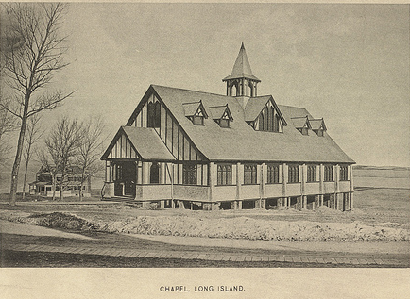
Chapel, Long Island Source: http://www.flickr.com/photos/boston_public_library/5640686608/in/photostream/

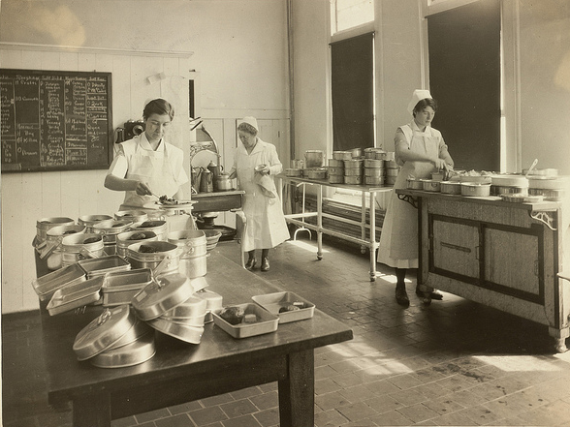
Nurses serving food in hospital on Long Island Source: http://www.flickr.com/photos/boston_public_library/5640115417/in/photostream/
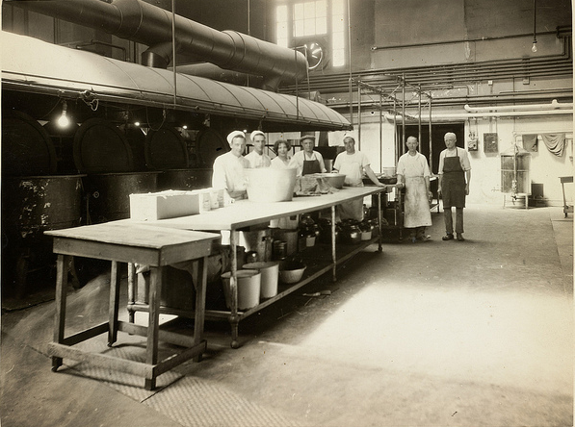
View of institutional food service employees on Long Island Source: http://www.flickr.com/photos/boston_public_library/5640115391/in/photostream/
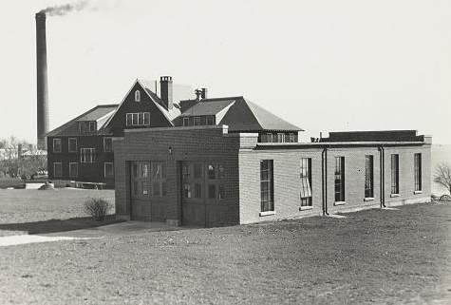
The firehouse on Long Island Source: http://www.flickr.com/photos/boston_public_library/

Submarine mines in U.S. harbor defense
Source: From Wikipedia, the free encyclopedia
A controlled mine (at right), with the distribution box that connected it and the other mines in its Group to the mine casemate on shore.
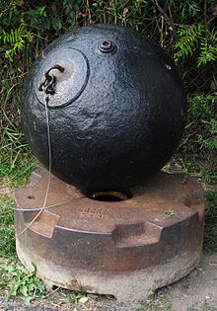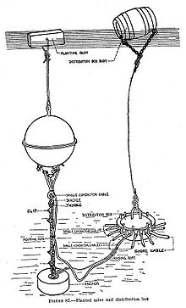
The modern era of defending American harbors with submarine mines began in 1886 with the report of the Endicott Board on harbor defense. From about 1900 until 1946 the mine defense program grew, until upwards of 10,000 controlled mines were maintained by the U.S. Army's Coast Artillery Corps.^{[1]}
Controlled mines were anchored to the bottom of a harbor, floating at depths of from 20 to 250 feet, and were fired electrically through a vast network of underwater electrical cables at each protected harbor. These cables terminated on shore in a massive concrete bunker called the mine casemate (see photo, below-right) that was usually buried beneath a protective covering of earth.
This casemate housed electrical generators, batteries, control panels, and troops that were used to test the readiness of the mines and to fire them when needed.^{[2]} The map of Boston Harbor's mine fields (below, right) shows the harbor mine defenses consisting of 30 groups of mines, with 19 mines per group. Each mine was normally loaded with 200 lbs. of TNT. So in Boston's case, a total of 57 tons of explosives guarded the harbor.^{[3]}
Each protected harbor also maintained a small fleet of mine planters and tenders that were used to lay the mines in precise patterns, haul them back up periodically to check their condition (or to remove them back to the shore during peacetime), and then lay them again.^{[4]} Each of these harbors also had on-shore facilities to store the mines and the TNT used to fill them, to load and transport the mines (which often weighed over 750 lbs. each when loaded), and to test and repair the electrical cables. Fire control structures were also built that were used first to observe the mine-laying process and fix location of each mine and second to track attacking ships, reporting when specific mines should be detonated (so-called "observed fire"). The preferred method of using the mines was to set them to detonate a set period of time after they had been touched or tipped, avoiding the need for observers to spot each target ship.
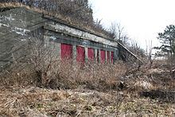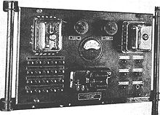
The mine casemate at Fort Strong, Long Island, Boston Harbor, once the control point for mines in the southern channels to the harbor. (above, left)
Each mine casemate (depending on local harbor conditions) controlled about 150 to 300 mines, arranged in Groups of 19.^{[5]} The mines in one Group were generally laid about 100 ft. apart, in lines running across the channel being protected (with 50 ft. or less on either end of the line). This meant that one Group of mines could protect a total distance of about 1900 ft. (650 yds.).^{[6]} If more Groups of mines were needed (as in Boston), multiple mine casemates were generally built and equipped (Boston had three mine casemates.^{[7]}).
A mine casemate mounted a control panel like this (above right) for each 19-mine group under its command. The controls were used to test and to fire the mines.
The shore cable from the underwater distribution box of each mine group was run back to a cable hut on the shore near the mine casemate, and from there to the casemate itself, where it was connected to a mine control panel (see photo at left, below). These panels were located in the casemate's Operating Room, pictured at left-center in the plan shown at right.
In addition to these firing controls, the mine casemate contained one or more electric generators and a large bank of storage batteries that made it possible to store the electricity for use later. The generators produced DC current, and an early form of a DC-AC converter (called an interrupter) was used to convert a portion of this current to AC.^{[8]} The casemate also had a number of telephone lines, keeping it in touch with remotely located mine observation and fire control fire control positions, with the mine commander, and with the gun batteries and searchlights that covered the mine fields. The casemate also contained switching and diagnostic equipment which was used to test the integrity of the cables running out to the mines and the functionality of the individual and group mine detonation switches.
Since the most busy mine casemate in Boston Harbor (for example) controlled 15 mine groups (285 mines), it would have mounted 15 of these mine control panels, plus many more related rack-mount devices for controlling the casemate's generators, inverters, and battery systems. When the Ft. Strong mine casemate was first opened (in 1907), its electrical and control systems could probably be described as "cutting edge technology." This was because in 1907, less than 10% of Boston's homes had been electrified, and then usually only with ceiling lights in a few rooms. The first Edison generating plant had only just come on-line in Boston in 1903, and Boston's first electric streetlights were not to be installed until six years later (1913).
The mine wharf was the place that minelayers tied up to load or unload their cargo of mines and connecting cable. This wharf was equipped with a heavy lifting crane. From the wharf, returning mines were carried by the mine tramway (running on the track shown on the map) to the torpedo storehouse ("torpedo" was another term used in place of "mine"). This storehouse was the largest building in the mine complex, and was used to store the mines, on large racks, when they had been pulled from the water for testing, repair, or storage (for example, when peace had broken out).^{[9]}
Another branch of the tramway lead to the loading room, where the TNT charges for the mines were loaded into or unloaded from the mines. A very small TNT storehouse was immediately adjacent to the loading room.^{[10]}
Yet another branch of the tramway track lead to the cable tanks. These were huge concrete tanks filled with seawater pumped from the harbor and used to do insulation and conductivity testing on the many miles of electrical cable that were used for mine operations. The torpedo storehouse had its own smaller tanks that were used for submergence testing of the mine casings and their fuzes, which were inserted into the casings through watertight plugs.

The Farm at Long Island Shelter
The Farm at Long Island Shelter helps feed hungry bodies, minds, and spirits. The Farm is a 4-acre organic vegetable, flower and herb farm located on Long Island in Boston Harbor. The Northeast Organic Farming Association certifies the Farm organic and recognizes it as using environmentally sound and sustainable agricultural practices.
Each year, The Farm produces nearly 30,000 pounds of high quality first harvest produce (eggs and honey too) for the over 800 homeless individuals we serve each day and has had a tremendous impact on the quality of food the individuals in our shelters and programs receive.
Beside delicious and nutritious produce for the people we serve, The Farm also provides hands-on job training, work-readiness skills, life skills and education for homeless individuals as part of the Serving Ourselves Job Training Program. Participants learn all aspects of food production; soil preparation, a variety of planting techniques, tending the plants, pest control, harvesting and marketing their produce at local farmers markets (approximately 15% is sold at Farmers Markets in Quincy and Boston which helps raise funds for the program).Source: http://www.fobh.org/the-farm--long-island
The Farm also gives those in the Culinary Arts track of Serving Ourselves the opportunity to work with a wide variety of vegetables and herbs, and learn skills that would otherwise not be possible due to prohibitive cost, like pickling, drying, and cooking with fresh herbs.
The experience gained in these programs has led to permanent, gainful employment in the restaurant, food, horticulture and landscaping industries. For example, one employee started a landscaping business, on is working with a well-known florist in Boston and another is pursuing her education and employment in floriculture.

Camp Harbor View
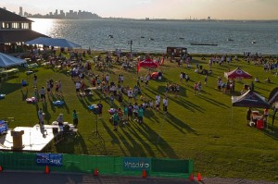
Created to offer Boston children a true summer camp experience, Camp Harbor View is an initiative of the not-for-profit Camp Harbor View Foundation, Inc. in partnership with the City of Boston and the Boys & Girls Clubs of Boston.
Camp Harbor View offers close to 800 children of all ages living in Boston’s at-risk neighborhoods the opportunity to leave the city during the day and participate in a four-week summer camp program. Offering the traditional activities that summer camp is known for, such as hiking, arts and crafts, sports and swimming, Camp Harbor View also includes innovative programs that strive to build children’s confidence and leadership strengths. Collaboration with our Program Partners provides the campers the opportunity for learning and discovery through a wide range of programs and activities brought to us by experts in their field.
Campers can attend one of two four-week long sessions during the months of July and August. Bus transportation is provided at no additional cost to families, picking campers up at 12 locations throughout Boston and departing camp each night at 6pm following the evening meal. Tuition for one camper is just $5 per four week session.
Once campers age out of the program, they are eligible to apply to the Camp Harbor View Counselor-in-Training (CIT) program. The CIT program keeps alumni campers ages 15 – 17 years old connected to Camp Harbor View through job readiness, training, college preparation and fun, both during summer camp sessions and year-round. Source: http://chvf.org/

Friends of Boston’s Homeless

Providing Solutions to Homelessness
Founded in 1987, Friends of Boston’s Homeless is a 501(C)(3) non-profit corporation working in partnership with Homeless Services of the Boston Public Health Commission to develop and fund innovative, solution-oriented programs to help the homeless move beyond shelter and back into the community as independent citizens. In addition, through advocacy and education, the Friends seeks to increase the public’s awareness and understanding of the realities of homelessness.
The Friends serves to bridge the gap between public sector funding and the current needs of the homeless by providing a vehicle for individuals, businesses, foundations and charitable organizations to be a part of the solution to homelessness.
The Homeless Services network provides basic shelter (bed, shower, food), comprehensive supportive services (health and mental health care, case management, substance abuse treatment and counseling), and, in partnership with Friends of Boston’s Homeless, transitional programs like job training and employment services, adult education and literacy, life skills development, and transitional and permanent affordable housing. Shelters associated with Homeless Services include Long Island Shelter (located in Boston Harbor) and Woods Mullen Shelter in the South End.
The Friends of Boston’s Homeless functions as the fundraising and public relations arm for the transitional programs run by Homeless Services. In addition, the Friends provides technical assistance and expertise in the development of new transitional programs and on-going improvement of existing programs to ensure the current and changing needs of the homeless are met.
In partnership with Homeless Services, the Friends of Boston’s Homeless programs now help over 200 homeless men and women each year move beyond shelter and back into the community with an education, gainful employment and permanent housing. The partnership is one of the largest providers of homeless services in New England. Source: http://www.fobh.org

Friends of the Boston Harbor Islands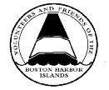

For many years (about 12) the Friends had a native species nursery/garden on Long Island. It started in the early 1990s. We have been offering special tours of Long Island for FBHI members over the years led by experts. We will be offering two sunset cruises to the island this year: July 20th and August 17th from 6:00-9:00.
The Volunteers and Friends of the Boston Harbor Islands Inc. evolved out of the efforts of the Boston Harbor Islands Volunteer Corps. The Corps was organized in 1979 by Suzanne Gall Marsh to supplement the program services of the Boston Harbor Islands State Park staff.
When the organization incorporated in 1982 the title was changed to include a variety of members - some who volunteer on land, sea, or the islands, and others who support the Friends mission and love the islands but do not necessarily have time to be volunteers. There is a three-fold mission: direct service to the park, public education programs including boat trips and advocacy efforts, all of which are done by volunteers.
The Friends predate the national park which was authorized by Congress in November 1996. During the years leading to the creation of the national park the Friends were deeply involved in the behind-the-scenes efforts of the feasibility study, the drafting of the legislation, and the advocacy efforts with the Massachusetts Congressional delegation. Source: www.fbhi.org
Over the years the Friends have been recognized by local, state, and national organizations for their dedicated grassroots efforts to promote the appreciation and preservation of this unique recreational resource, located so near to a major metropolitan area.
Awards for the Friends
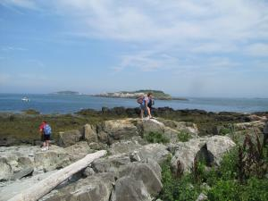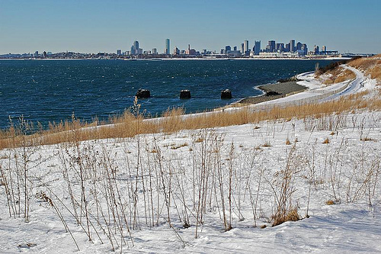
During these years the Friends volunteers have provided thousands of hours of service assisting park visitors and managers. They greet and guide visitors, help to maintain island structures and environmental sites, work with youth through specialized programming and work on boat cruises that introduce passengers to the islands of the park. They are ardent advocates promoting the park in the political arena and the larger community. Through these efforts they help ensure that visitors to Boston Harbor can enjoy one of America's unique places, a park of natural beauty just a short boat ride from the city's edge.
In recent years the excellence of the Friends of the Boston Harbor Islands has been recognized by state, local and national organizations. FBHI was recognized by the National Park Service as an outstanding volunteer program in 2002 when the organization received the George B. Hartzog, Jr. Award for Outstanding Volunteer Service
The Friends also received the President's award from the National Association of State Park Directors. The (NASPD) award is given annually to a nominee who has demonstrated a commitment to furthering the mission of a host state park agency. In their nominating letter, the Massachusetts Department of Environmental Management, (now merged with the former Metropolitan District Commission to create the current Department of Conservation and Recreation) said "We, and other partners in the Boston Harbor Islands park partnership are lucky to be able to rely on an independent, adaptable and well-managed volunteer program".
The Friends now serve the national park with its 34 islands spread over 50 square miles of Boston Harbor. It is truly one of America's Great Parks with its panoramic vistas, sweeping beaches, historic forts, schools and hospitals, miles of walking trails, and acres of natural landscapes. The organization takes great pride in serving this historic treasure.

This project was located on Long Island
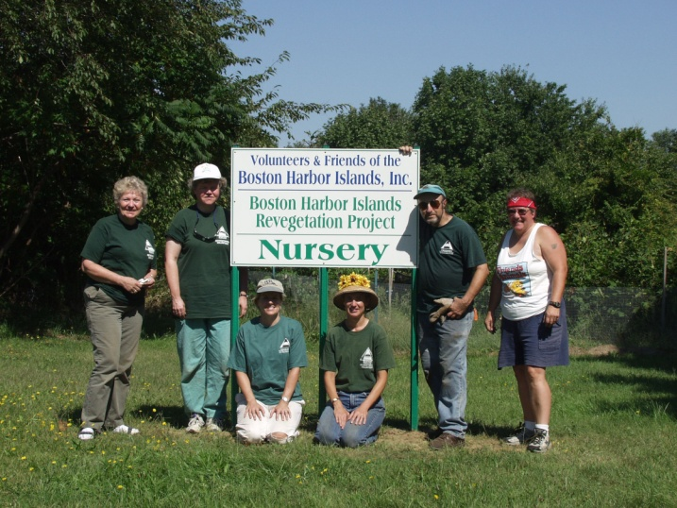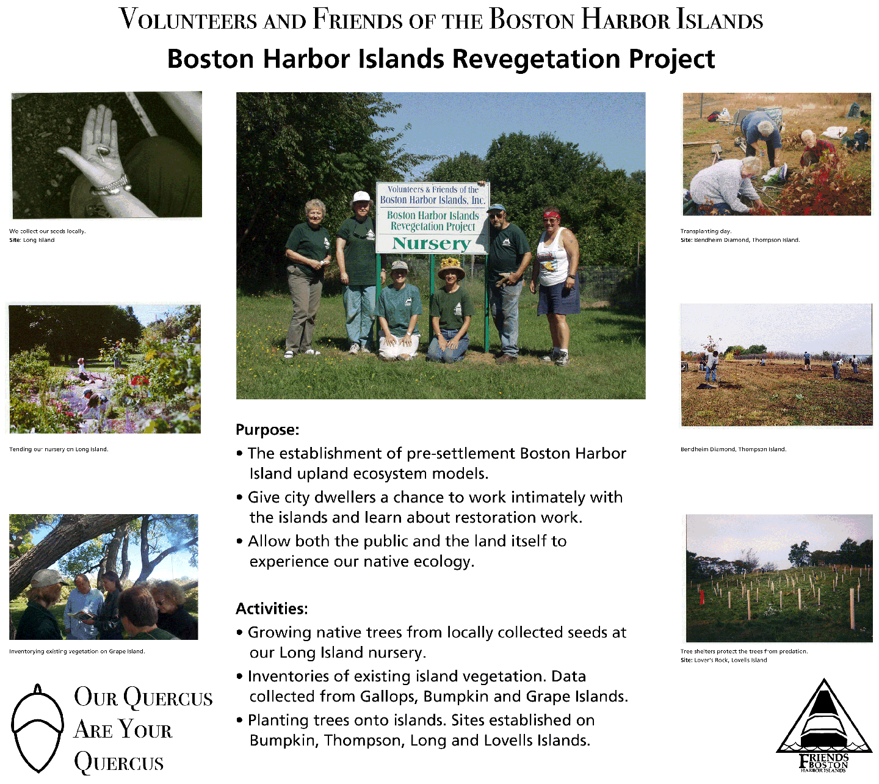
(note: this project has ended) Booklet formatted by Walter Hope, April 2011

